Not filed TDS Return-File NIL Declaration on Traces

The last date for filing the TDS Statements for the Second Quarter of FY 2014-15 is already over. There will be many deductors who did not deduct any tax during the relevant quarter and therefore did not file any statement for deduction of tax at source u/s 200(3) of the Income Tax Act’1961But do you know that for such deductors who have a TAN Number but have not filed the TDS statement as they did not deduct any tax during the relevant tax period, CPC (TDS) has started a functionality where the deductors can file a NIL Declaration i.e a declaration that the deductor did not deduct any tax during the relevant tax period and was subsequently not liable to file a tds statement.
Ques: What is a NIL Declaration of TDS Statement?
Ans: A NIL Declaration is basically a declaration for non-filing of TDS Statements for those deductors who were not liable to deduct any tax during the relevant quarter or have not deducted tax during any quarter and subsequently did not file a TDS Statement U/s 200(3) of the Income Tax Act’1961 for any quarter.
Ques: Is it mandatory to file a NIL Declaration?
Ans: As per Income Tax Act’1961 and the Income Tax Rules it is not mandatory file a NIL TDS Return.
Since filing NIL TDS Return was neither mandatory nor possible. The CPC (TDS) was having a problem distinguishing between:
- Deductors required to file return but not filed the TDS Return.
- Deductors not required to file return.
Therefore, In order to prove that the deductor was not required to file a TDS Return, it is advisable that the deductors should file A NIL Declaration of TDS Statement.
Ques: Where can I file a declaration for not filing a TDS Statement?
Ans: A Declaration for not filing the TDS Statement can filed by logging into the CPC (TDS) Website: www.tdscpc.gov.in
Ques: What is the procedure for a filing a Declaration for not filing TDS Statement/NIL Declaration?
Ans: Procedure for filing of declaration for non-filing of TDS statement is given below:
- Login through your registered id at www.tdscpc.gov.in
- Go to “Statement/Payments TAB after login >then declaration for Non filing of TDS statement (as shown in the picture below).
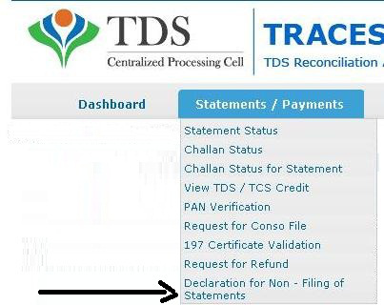

- On clicking declaration for Non filing of TDS statement link you will get screen with options as shown below:
- Select financial year.
- Select Quarter.
- Select Fom type- 24Q, 26Q, 27Q or 27EQ.
- Select reason for non-filing of statement from drop down menu.

All fields are mandatory to fill.
- In the Financial year option, the system shows 2013-14 and 2014-15. It means that a Declaration for non-filing of TDS Statement can filed for these two years only.
- In the Reasons column, the deductor can choose from the following options as shown below:
- Not liable to deduct for the selected statement period.
- No Payment made/ Credit to Deductee.
- Temporarily Business Closed
- Permanently business closed
- Payment below threshold to deductee
- Branch Shifted
- Any other reason

COURTESY:
Source :TAXGURU.COM
20/10/2014

